**PROJECT BASED LAB REPORT**

**On**

**STUDENT COUNSELLING SYSTEM**

**Submitted in partial fulfilment of the**

**Requirements for the award of the Degree of**

**Bachelor of Technology**

**in**

**ELECTRONICS AND COMMUNICATION ENGINEERING**

**By**

**ROHINI PANDIRI 2100031934**



**DEPARTMENT OF ELECTRONICS AND COMMUNICATION ENGINEERING**

**K L University**

Green Fields, Vaddeswaram, Guntur District-522 502

**2016-2017**

**K L University**

**DEPARTMENT OF ELECTRONICS AND COMMUNICATION ENGINEERING**



***CERTIFICATE***

This is to certify that this project based lab report entitled **“STUDENT COUNSELLING SYSTEM”** is a bonafide work done ROHINI PANDIRI 2100031934 in partial fulfilment of the requirements for the award of degree in **BACHELOR OF TECHNOLOGY** in **ELECTRONICS AND COMMUNICATION ENGINEERING** during the Academic year 2016-2017.

**Faculty in Charge Head of the Department**

P.Aruna Sri Dr.A.V.S.C.S.Sastry

**Project Guide**

P.Aruna Sri

**KL UNIVERSITY**

**DEPARTMENT OF ELECTRONICS AND COMMUNICATION ENGINEERING**



***DECLARATION***

We hereby declare that this project based lab report titled **“STUDENT COUNSELLING SYSTEM”** has been prepared by us in partial fulfilment of the requirements for the award of degree “**BACHELOR OF TECHNOLOGY in ELECTRONICS AND COMMUNICATION ENGINEERING** ” during the Academic year 2016-2017.

We also declare that this project based lab report is of our own efforts and it has not been submitted to any other university for the award of any degree.

**ROHINI PANDIRI 2100031934**

**ACKNOWLEDGEMENT**

Our sincere thanks to**Mrs.P.S.G.Aruna Sri** in the Lab for their outstanding support through out the project for the successful completion of the work.

We express our gratitude to **Dr.A.S.C.S.Sastry,** Head of the Department for Electronics and communication Engineering for providing us with adequate facilities, ways and means by which we are able to complete this project based Lab.

We would like to place on record the deep sense of gratitude to the honourable Vice Chancellor, K L University for providing the necessary facilities to carry the project based Lab.

Last, but not the least, we thank all Teaching and Non-Teaching Staff of our department and especially my classmates and my friends for their support in the completion of our project based Lab.

**ROHINI PANDIRI 2100031934**

**TABLE OF CONTENTS**

|  |  |
| --- | --- |
| **S. NO** | **CONTENT** |
| **1.** | **ABSTRACT** |
| **2.** | **INTRODUCTION** |
| **3.** | **FUNCTIONAL REQUIREMENTS** |
| **4.** | **NON - FUNCTIONAL REQUIREMENTS** |
| **5.** | **CODE** |
| **6.** | **OUTPUT** |
| **7.** | **CONCLUSION** |
| **8.** | **FUTURE SCOPE** |

**ABSTRACT**

The main idea of the project is to display the courses offered by a college or a university to the student who attends the counselling .Then the student has to select the branch he is willing to register in. Then it is verified whether he/she can register in that branch or not according to their rank. If the student is eligible for the selected branch then it displays the availability of the seats in the selected branch. If the student wants to register for the selected branch and if he is eligible for it then he has to enter his details . At last it displays the seat confirmation message. This project is very useful during the Counselling’s held in universities or colleges.

In this program we are going to use methods and we should create an object. We are also using Switch case and if condition in this program. Also we are using exception handling and storing the information of the students registered in files.

**INTRODUCTION**

A **Student counselling system** is an element that focuses mainly on the administrational needs of a university/college. In many implementations, a Student counselling system is a comprehensive, integrated [information system](http://en.wikipedia.org/wiki/Information_system) designed to manage all the aspects of a universities operation, such as registration of all the newly candidates who wish to join in the university.

One of the most important issues is the administrational services provided by the university .Student counselling system provides assistance to the students by providing the informatics regarding the courses offered.

Student counselling system provide a common source of information about a the branches offered by the university . The system have to keep data in secure place and controls who can reach the data in certain circumstances. These systems enhance the ability of administration system of the university to coordinate the details of all the students registered to vivid branches..

**What is Student Counselling System?**

The student counselling system is very useful to register in any of the branch according to your rank. If your are eligible for the branch you have selected then it asks to enter the details of you to register.

**Problem Definition**

The main reason to develop this type of program is to make the students comfortable for counselling and to save the time. It is difficult to check for every student wether he is eligible for the particular branch or not. By using this program we can complete the counselling system in an easier way.

**DESCRIPTION**

The project is done based on java programming. This is through object oriented programming. This gives some necessary information regarding the counselling of students after completing their intermediate (+2).If they wish to join in our university, after getting qualified for the “KLUEEE”, this program will definitely be helping them to a great extent.

As our university is having a number of branches ,they allot seats for the freshers based on their ranks in “klueee”. So this programming will guide the student properly in order to select the seat in his desired branch. The counselling system is designed based on the ranks and so the seat will also be done according to that only. Thus ,this will help both the university and the students to a large extent. After the registration has been done, his/her information will be stored in the files for the future use.

**FUNCTIONAL REQUIREMENTS**

**Purpose**  
 The purpose of doing this project is to provide all the information regarding the branches available in the university and to make the freshers understand the policy of rank based allotment of seats. Thus they can register to our university and can get the seats allotted.

|  |  |  |
| --- | --- | --- |
| **1.** | **BRANCHES INFORMATION** | Displays the available branches in the university for students . |
| **2.** | **RANK BASED ALLOTMENT OF SEATS** | Students get their seats according to their ranks in KLUEE |
| **3.** | **GUIDELINES** | helps in guiding a student to register, in an eased manner |

**NON-FUNCTIONAL REQUIREMENTS**

METHODS:

Carries the necessary instructions or processes to be done in the programme

IF-ELSE:

Checks the input ,whether satisfying the programmers condition and then proceeds the programme .otherwise guides to go back .

SWITCH CASE:

Does the process according to the choice selected by the user.

OUTPUT STREAM:

Creates a file in order to store the input (or)stores the data in the file if it is already created.

**EXCEPTION HANDLING:**

An exception (or exceptional event) is a problem that arises during the execution of a program. When an Exception occurs the normal flow of the program is disrupted and the program/Application terminates abnormally, which is not recommended, therefore, these exceptions are to be handled.

**CODE:**

import java.io.*;

import java.util.*;

class Coun

{

publicvoid cse()throws IOException

{

Scanner s=new Scanner(System.in);

int r;

System.out.print("\n\n\t\t enter your rank:");

r=s.nextInt();

if(r<=1000)

{

String Name,Fathername;

System.out.print("\n\n\t\t enter ur name:");

Name=s.next();

System.out.print("\n\n\t\t enter ur fathers name:");

Fathername=s.next();

System.out.print("\n\n\t\t"+Name+"\tyou have succesfully registered your seat in CSE branch ");

File fil=new File("cse.txt");

if(!fil.exists())

{

fil.createNewFile();

}

BufferedWriter bw=new BufferedWriter(new FileWriter("cse.txt",true));

bw.write("Student name: "+Name+" ");

bw.write("Fathername: "+Fathername+" ");

bw.write("\n");

bw.newLine();

bw.close();

}

else

{

System.out.print("\n\n\t\t you are not eligible for CSE");

}

}

publicvoid ece()throws IOException

{

Scanner s=new Scanner(System.in);

int r;

System.out.print("\n\n\t\t enter your rank:");

r=s.nextInt();

if(r<=2000)

{

String Name,Fathername;

System.out.print("\n\n\t\t enter ur name:");

Name=s.next();

System.out.print("\n\n\t\t enter ur fathers name:");

Fathername=s.next();

System.out.print("\n\n\t\t"+Name+"\tyou have succesfully registered your seat in ECE branch ");

File fil=new File("ece.txt");

if(!fil.exists())

{

fil.createNewFile();

}

BufferedWriter bw=new BufferedWriter(new FileWriter("ece.txt",true));

bw.write("Student name:"+Name+" ");

bw.write("Father name: "+Fathername+" ");

bw.write("\n");

bw.newLine();

bw.close();

}

else

{

System.out.print("\n\n\t\t you are not eligible for ECE");

}

}

publicvoid ecm()throws IOException

{

Scanner s=new Scanner(System.in);

int r;

System.out.print("\n\n\t\t enter your rank:");

r=s.nextInt();

if(r<=3000)

{

String Name,Fathername;

System.out.print("\n\n\t\t enter ur name:");

Name=s.next();

System.out.print("\n\n\t\t enter ur fathers name:");

Fathername=s.next();

System.out.print("\n\n\t\t"+Name+"\tyou have succesfully registered your seat in ECM branch");

File fil=new File("ecm.txt");

if(!fil.exists())

{

fil.createNewFile();

}

BufferedWriter bw=new BufferedWriter(new FileWriter("ecm.txt",true));

bw.write("Student name: "+Name+" ");

bw.write("Father name: "+Fathername+" ");

bw.write("\n");

bw.newLine();

bw.close();

}

else

{

System.out.print("\n\n\t\t you are not eligible for ECM");

}

}

publicvoid eee()throws IOException

{

Scanner s=new Scanner(System.in);

int r;

System.out.print("\n\n\t\t enter your rank:");

r=s.nextInt();

if(r<=3000)

{

String Name,Fathername;

System.out.print("\n\n\t\t enter ur name:");

Name=s.next();

System.out.print("\n\n\t\t enter ur fathers name:");

Fathername=s.next();

System.out.print("\n\n\t\t"+Name+"\tyou have succesfully registered your seat in EEE branch");

File fil=new File("eee.txt");

if(!fil.exists())

{

fil.createNewFile();

}

BufferedWriter bw=new BufferedWriter(new FileWriter("eee.txt",true));

bw.write("Student name: "+Name+" ");

bw.write("Father name: "+Fathername+" ");

bw.write("\n");

bw.newLine();

bw.close();

}

else

{

System.out.print("\n\n\t\t you are not eligible for ECM");

}

}

Publicvoid me()throws IOException

{

Scanner s=new Scanner(System.in);

int r;

System.out.print("\n\n\t\t enter your rank:");

r=s.nextInt();

if(r<=5000)

{

String Name,Fathername;

System.out.print("\n\n\t\t enter ur name:");

Name=s.next();

System.out.print("\n\n\t\t enter ur fathers name:");

Fathername=s.next();

System.out.print("\n\n\t\t"+Name+"\tyou have succesfully registered your seat in ME branch");

File fil=new File("me.txt");

if(!fil.exists())

{

fil.createNewFile();

}

BufferedWriter bw=new BufferedWriter(new FileWriter("me.txt",true));

bw.write("Student name: "+Name+" ");

bw.write("Father name: "+Fathername+" ");

bw.write("\n");

bw.newLine();

bw.close();

}

else

{

System.out.print("\n\n\t\t you are not eligible for ME");

}

}

publicvoid disp()

{

Scanner s=new Scanner(System.in);

System.out.print("\n\t 1.cse");

System.out.print("\n\t 2.ece");

System.out.print("\n\t 3.ecm");

System.out.print("\n\t 4.eee");

System.out.print("\n\t 5.me");

}

}

publicclass S

{

publicstaticvoid main(String args[])

{

int i;

System.out.print("\n\n\t\t WELCOME TO KL UNIVERSITY");

System.out.print("\n\n\t\t The branches offered in our university are:");

Coun O=new Coun();

O.disp();

Scanner s=new Scanner(System.in);

System.out.print("\n\t ENTER UR CHOICE:");

i=s.nextInt();

switch(i)

{

case 1:

try

{

O.cse();

}

catch(Exception e)

{

System.out.println("error");

}

break;

case 2:

try

{

O.ece();

}

catch(Exception e)

{

System.out.println("error");

}

break;

case 3:

try

{

O.ecm();

}

catch(Exception e)

{

System.out.println("error");

}

break;

case 4:

try

{

O.eee();

}

catch(Exception e)

{

System.out.println("error");

}

break;

case 5:

try

{

O.me();

}

catch(Exception e)

{

System.out.println("error");

}

break;

}

}

}

**OUTPUT:**

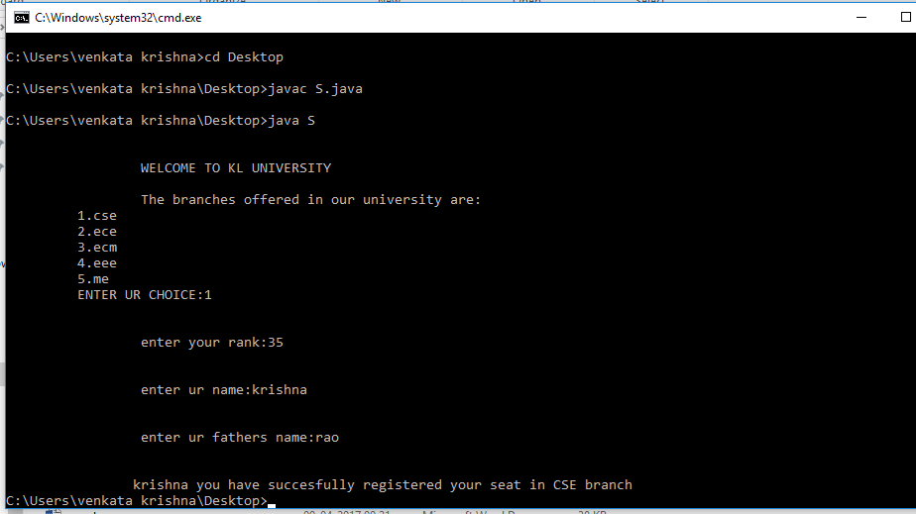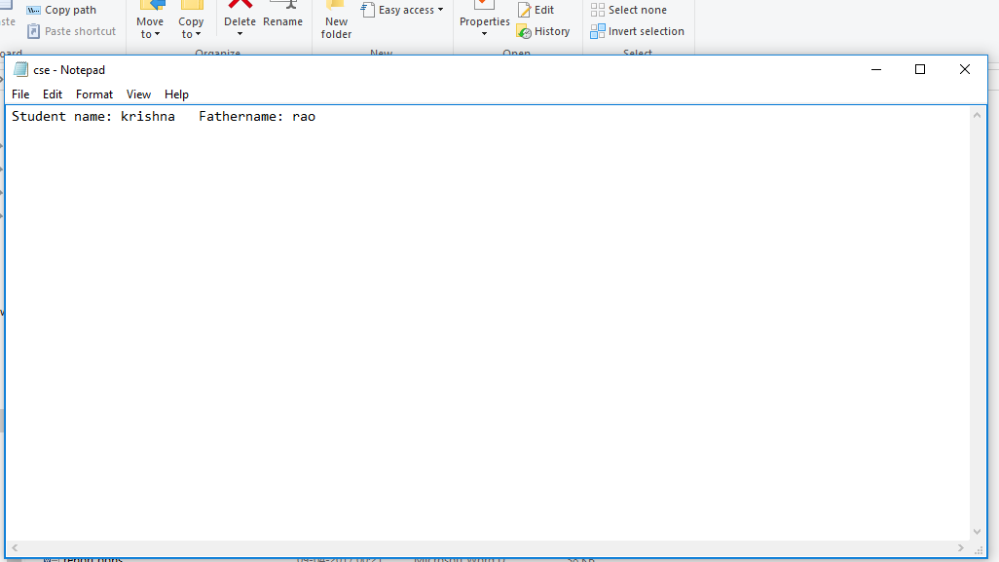

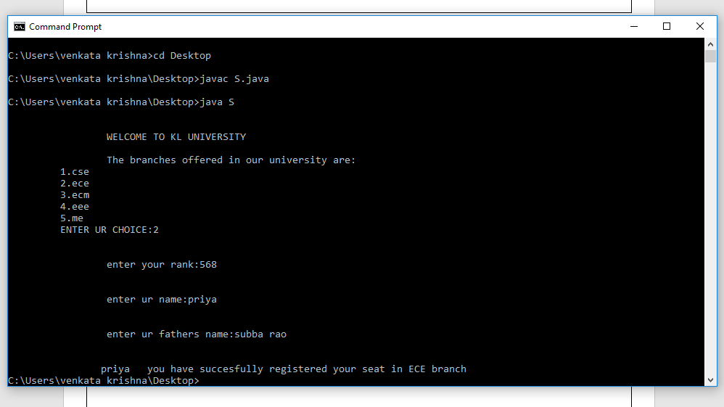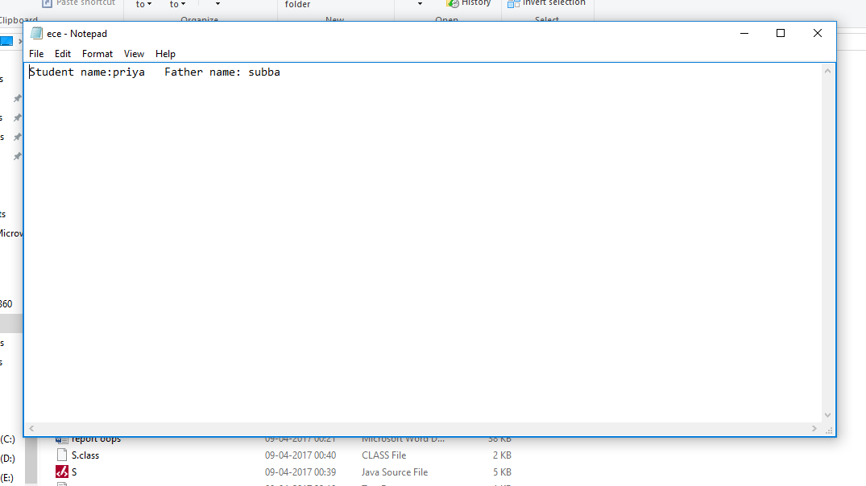

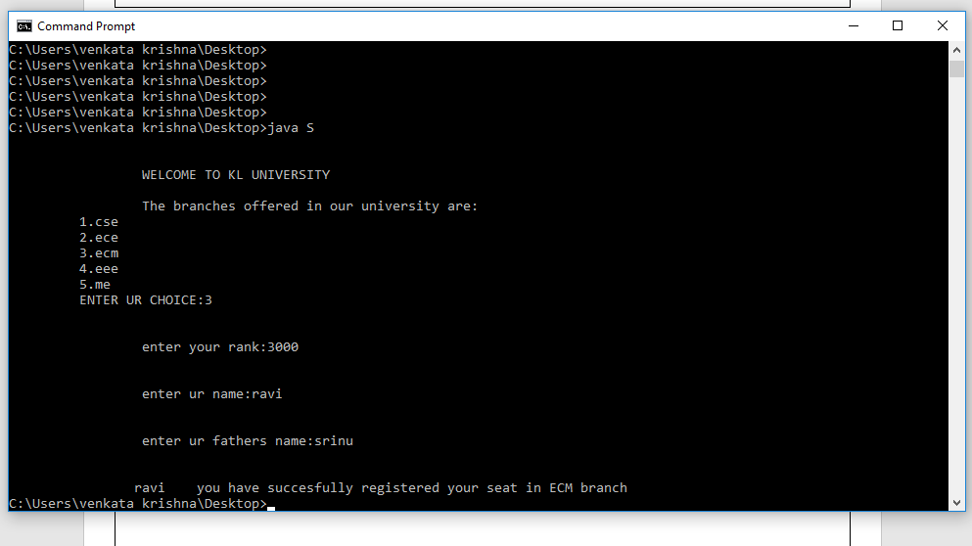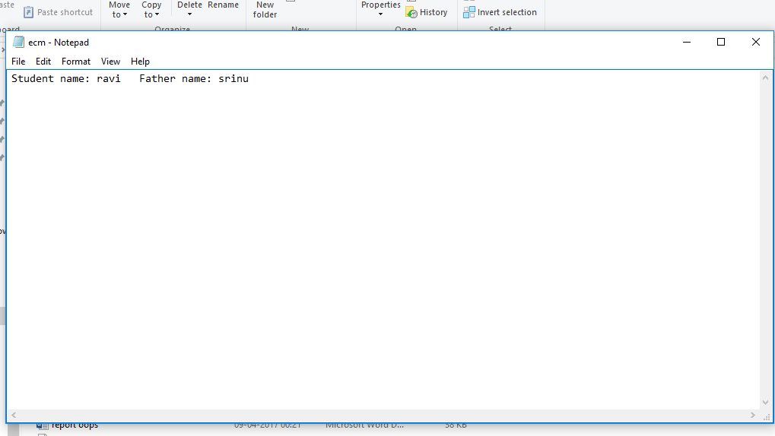

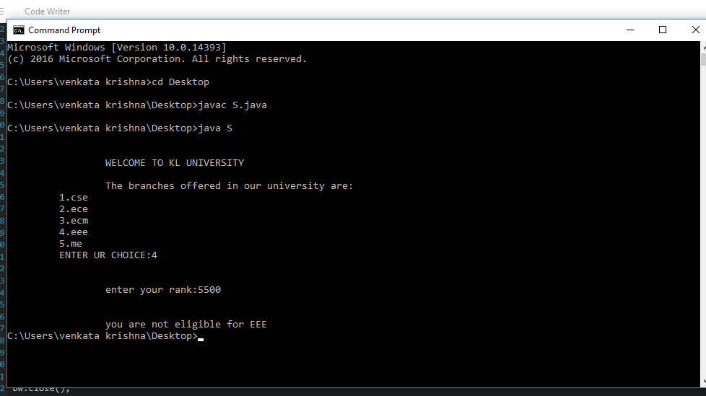

**Conclusion**

The project is successfully completed to the extent possible. The results of the project are shown earlier.

**Future Scope**

Some more functions or modules may be added to project. After studying and understanding Graphic User Interface (GUI) of java, the inputs and outputs can be improved and implemented using GUI.